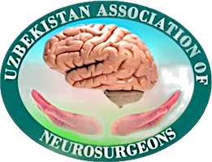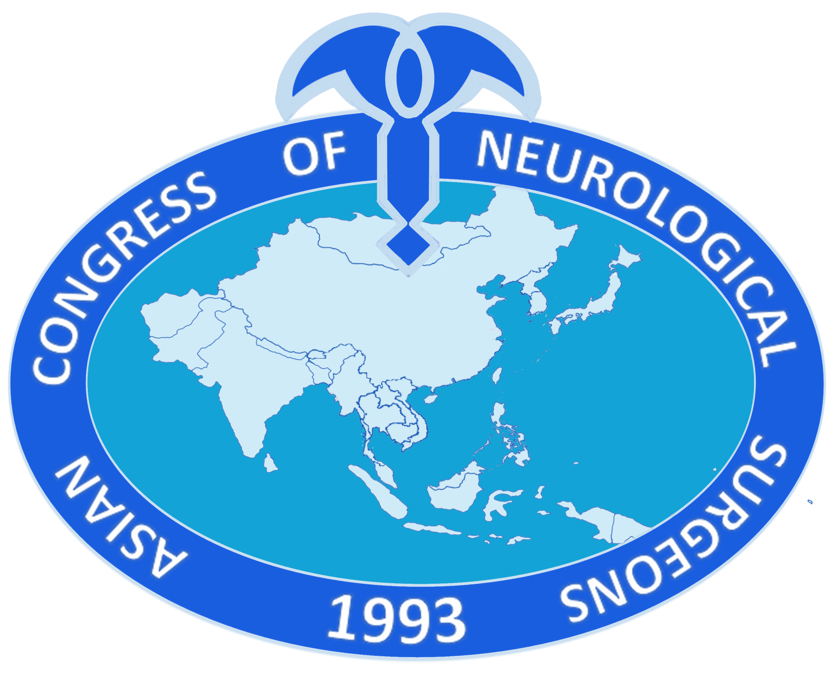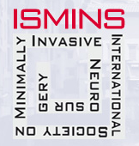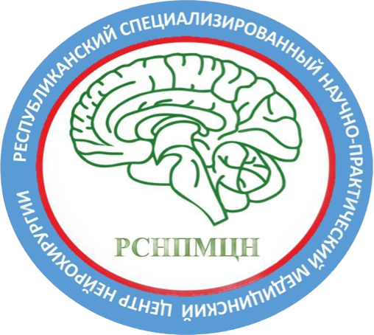
MINISTRY OF THE HEALTH OF THE REPUBLIC OF UZBEKISTAN
REPUBLICAN SCIENTIFIC~PRACTICAL MEDICAL CENTER OF NEUROSURGERY
UZBEKISTAN ASSOCIATION OF NEUROSURGEONS
ASIAN CONGRESS OF NEUROLOGICAL SURGEONS
INTERNATIONAL SOCIETY OF MINIMALLY INVASIVE NEUROSURGERY

Dear colleagues!

Republican Specialized Scientific-Practical Medical Center for Neurosurgery of Uzbekistan has the honor to invite you to participate in Central Asian Congress and Workshop, in cooperation with the International Society for Minimally Invasive Neurosurgery and the Asian Congress of Neurological Surgeons

“Joint ACNS Congress of Central Asian neurosurgeons “Silk Road” &
7th Congress of International Society of Minimally Invasive Neurosurgery”

DATE: September 15-17 2023
VENUE: Hotel «International» Amir Temur str. 107а, Tashkent. Uzbekistan

ORGANIZERS:

- Republican Specialized Scientific -Practical Medical Center for Neurosurgery of Uzbekistan
- Uzbekistan Association of Neurosurgeons
- Asian Congress of Neurological Surgeons (ACNS)
- International Society for Minimally Invasive Neurosurgery (ISMINS

Congress Presidents:
Prof. Kariev Gayrat Maratovich (Director RSSPNCN, President of Uzbekistan Association of Neurosurgeons)
Prof.Yoko Kato (Patron, President of ACNS and International Society for Minimally Invasive Neurosurgery ISMINS)
academician Akshulakov Serik Kuandikovich (Chairman of the Board of JSC National Center for Neurosurgery of Kazakhstan, President of the Association of Neurosurgeons of Kazakhstan)
academician Mamytov Mytalip Mamytovich (President of the Association of Neurosurgeons of Kyrgyzstan)

Vice-President: Xu Bin professor of neurosurgery University of Fu Dan, hospital Huashan, China.

Organizing secretariat:
Mamadaliev Dilshod Mukhammadvalievich secretary of Uzbekistan Association of Neurosurgeons
Prof. Azmi Alias MBBS, MMED Surgery, FRCS. Secretary of International Society for Minimally Invasive Neurosurgery ISMINS
Boon Seng Liew secretary of АCNS, neurosurgeon of Park City Medical Centre, Kuala Lumpur. Malaysia
Ng Chat Fong Secretary of ACNS YNS Committee. Associate consultant Queen Elizabeth Hospital Hong Kong, IT Committee member of the Hong Kong Neurosurgical Society.

Congress format: Hybrid

Local organizing committee:

Asadullaev U.М. Chief physician of RSSPMSN
Yuldashev R.М. Deputy director of RSSPMSN
Кim А.А. Deputy director of RSSPMSN
Yugay I.А. Scientific secretary of RSSPMSN
Akhmediev М.М. Chairman of pediatric neurosurgery department
Yakubov J.B. Chairman of skull base neurosurgery department
Burnashev М.I. Chairman of vascular neurosurgery department
Djumanov К.N. Chairman of spinal neurosurgery department
Аrslanova Z.E. Organizing methodological department
Khodjimetov D.N. Deputy Chief Physician of RSSPMSN

ISMINS and ACNS organizing committee members:
Yoko Kato President of ISMINS and ACNS. Chair. Professor of neurosurgery at Fujita Health University. Japan
Lucia Benvenuti Assistant secretary of ISMINS prof. of neurosurgery. Italy
M. Balamurugan Treasurer ISMINS prof. of neurosurgery. India.
Armando Basso co-founder ISMINS prof. of neurosurgery. Argentina.
Maurice Choux advisory board member ISMINS. prof. of neurosurgery. France.
Kentaro Mori advisory board member ISMINS prof. of neurosurgery. Japan.
Masaki Taniguchi advisory board member ISMINS prof. of neurosurgery. Japan.
Concezio Di Rocco founding member ISMINS. prof. of neurosurgery. Германия.
Ling Feng founding member vice president ISMINS. China.
Fuminari Komatsu executive board member ISMINS. prof. of neurosurgery. Japan.
Micheal Lawton executive board member ISMINS, prof. of neurosurgery. USA.
Vladimir Benes. executive board member ISMINS. prof. of neurosurgery. Чехия
Mahmood Qureshi executive board member ISMINS, prof. of neurosurgery. Kenya
Enrique Osario executive board member ISMINS, prof. of neurosurgery. Colombia
Asra Fauzi executive board member ISMINS, prof. of neurosurgery. Indonesia
Scientific tracts:

- Vascular neurosurgery
- Neurooncology
- Spinal neurosurgery
- Neurotraumatology
- Neurophysiology
- Skull base surgery

- Neurosurgery of peripheral nerves
- Functional neurosurgery
- Pediatric neurosurgery
- Intensive therapy in neurosurgery anesthesiology and resuscitation in neurosurgery

Workshop, Live surgery:
In the frames of the congress, on the first day (15.09.2023) it is planned to hold a practical course - a workshop on vascular neurosurgery (bypass techniques, endovascular treatment of aneurysms and stenting skills) as well as live surgeries of complicated cases (15.09-16.09) by leading experts of Japanese neurosurgeons.

Language: English.
(Synchronous translation will be provided)

PARTICIPATION:

- Abstract submission
- Poster presentation
- Oral presentation
- An ordinary participation

Abstracts: will be collected as an abstract book for the congress materials.
Abstract submission guidelines (only in english):

- First line: Abstract name (bold and capitalized)
- Second line: Full name of the authors.
- Third line: Affiliation (full name, if several authors from different affiliation, then please indicate.)
- Fourth line: city, organization, contact e-mail, telephone number of corresponding author
- Structure: (max. 350 words)
- Background,
- Aim
- Methods
- Results
- Conclusion
- Keywords

Page margins should be the same throughout the text - 1.0 cm. Tables and figures are not allowed.
• Abstracts are accepted only in English in Microsoft WORD (docx. Or 97-2004 at least).
• The volume of abstracts should be no more than 2 pages of A4 format, Times New Roman, 12 with an interval of 1.5.
• For YNS - it should be indicated the desire to make an oral or poster presentation.
• One author may publish not more than two abstracts.
• Text of the abstract must be checked thoroughly. The authors are responsible for the reliability of the data and the scientific content of the work.
• Standard abbreviations are allowed and must be transcribed in the first use.
 YNS contest

Congress encouraging our young neurosurgeons for the YNS contest which is planned on the third day of the congress (17.09.2023) who are not older 35 at the moment of abstract submission. Depending on the clarity and originality of the idea of the scientific research, strong evidence base (as well as personal profile, statistical data, etc.), clear conclusions of the presentation, first 3 places in the competition will be awarded. Presenters willing to attend, should send their presentations and abstracts named as a "for YNS contest from ….." We request you to send us your CV also.
Abstract submission deadline: July 1. 2023.
We request you to send your abstract and presentations not later than given deadline otherwise they will not be accepted.
Please send your abstract and presentations to the following secretary of the congress:
Mamadaliev Dilshod Mukhammadvalievich
E-mail: dr.mdm@mail.ru Contact tel.number (Telegram): (998-93)108-08-02
Organizing secretariat.

REGISTRATION

All congress participants will be provided with congress materials and name badges, which are a pass to scientific meetings and an exhibition.
Registration of all participants is required.
Please fill in the application form of registration - HERE

.
REGISTRATION FEE

RESIDENTS OF UZBEKISTAN. We request transfer your registration fee to the following account:
«Uzbekistan Association of Neurosurgeons» Tashkent, Uzbekistan,
М.Ulugbek region. Khumayun 40
Acc.number: 2021 2000 9049 8446 2001
Inter branch turnover 00431 Taxpayer Identification Number: 207146456

FOREIGN PARTICIPANTS are requested to transfer registration fee to the following account number:
«Uzbekistan Association of Neurosurgeons» Tashkent, Uzbekistan,
М.Ulugbek region. Khumayun 40
Account number for USD: 2021 2978 4049 8446 2001
Inter branch turnover 00431 Taxpayer Identification Number: 207146456

Registration fee including: congress programm, certificates and materials of the congress.
(* We remind you that the registration fee does not include hotel accommodation, and the participant must book a hotel in advance)

Participants | Early registration until 12.09.2023  (Including this date) | Registration after 12.09.2023  (Including this date)
Uzbekistan neurosurgeons (who has payed membership fee of the Association of Uzbekistan Neurosurgeons) | 400 000 UZS | 500 000 UZS
Non members of the Association | 750 000 UZS | 850 000 UZS
Foreign neurosurgeons | 50 USD | 60 USD
Residents, YNS who are not finished their residency program | 0 | 0

Accommodation
Organizing committee is not providing to participants accommodation. We kindly request you to book the nearest hotel in advance and find a useful information about hotels on the website - www.booking.com

GALA DINNER
Congress organizing committee offers a gala dinner – 570 000 UZS (50 USD)
*There are available online methods of payment via visa card (for the foreign participants), and online applications e.g. click, payme for Uzbekistani participants.

CONTACTS

Mamadaliev Dilshod Mukhammadvalievich- +998931080802
Arslanova Zera Enverovna- +998935900740
Kind regards,

Organizing secretariat

